TeamUnify: Declare/commit/sign up for upcoming meets
To commit an athlete or athletes for an event:
- Go to the Events tab and find the desired meet
- Meet details are found by clicking on the name of the meet.
- Then click on meet letter found under Forms/Documents.
- To return to meet sign up screen click on back arrow.
- Click Attend/Decline or Edit Commitment below the desired meet
- Scroll down to see all the members on the account. Click Athletes Name
- Select the Declaration (yes or no) for that specific athlete. Add any notes for the coach.
- Once Yes, please sign member up for this event is entered, scroll down the screen to select desired events for member.
- Click Save Changes found at the bottom of the page.
- Repeat steps for other members. Remember to Save Changes.
- Coach will may make changes and then approve events. Coach approved events will have a red check mark in the meet events area.

Instructions for OnDeck: Declare/commit/sign up for upcoming meets
OnDeck allows you to sign up your athletes for upcoming meets and events (currently available on Android and coming soon for iOS). There are three kinds of events and the process is almost identical for each—select an athlete, select Yes or No if they will attend, enter any notes, and possibly select days/sessions or events.
To access any of these, tap Menu > Events > Events & Meet Entries. Once you tap RSVP or EDIT COMMITMENT for a meet, you can tell what kind of meet it is at the top:


Yes/No Events
- Tap RSVP by event.
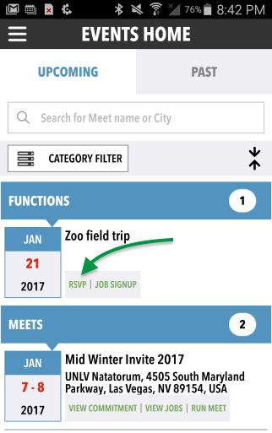
- Tap an athlete's name.
- Select No, thanks or Yes, please if they will attend.
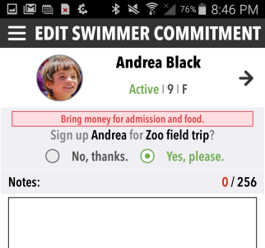
- Optionally enter any Notes.
- Tap SAVE CHANGES and then OK.

Commit by Session Meets
- Tap EDIT COMMITMENT by meet (it will say VIEW COMMITMENT if the registration deadline has passed, in which case you can view but not edit your commitments).
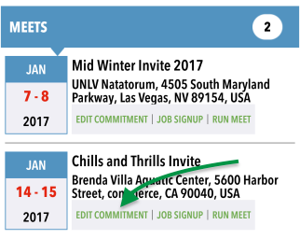
- Tap an athlete's name.
- Select No, thanks or Yes, please if they will attend.
- Optionally enter any Notes.
- You may tap the up arrow by the Yes/No radio buttons to hide notes and make more room for days/sessions.
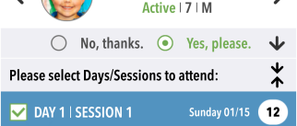
- Select Days/Sessions to attend.
  - ﻿Tap a Day/Session blue bar to see all events for that session.
- Tap SAVE CHANGES and then OK.

Commit by Event Meets
- Tap EDIT COMMITMENT by meet.
- Tap an athlete's name.
- Select No, thanks or Yes, please if they will attend.
- Optionally enter any Notes.
- You may tap the up arrow by the Yes/No radio buttons to hide notes and make more room for days/sessions.
- Tap a Day/Session blue bar to see all events for that session.
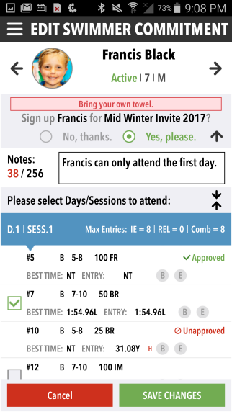
- Check the boxes by events you want them to attend. A coach will need to approve them.
- Tap SAVE CHANGES and then OK.

